Indiana Association of Medical Staff Services (INAMSS)
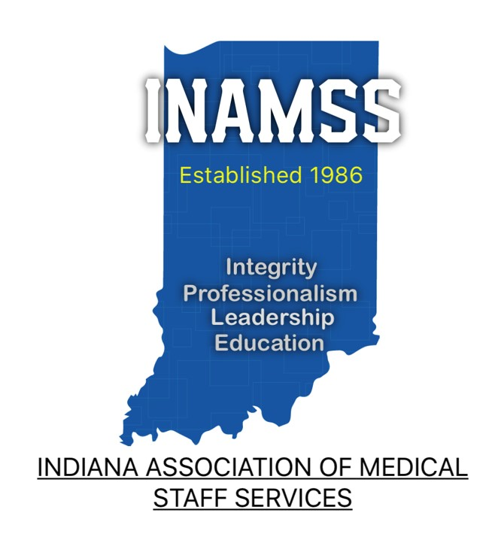
Business Meeting and Education Conference
October 25, 2024

A special thank you to our Sponsors!


Friday, October 25, 2024
8:30 am – 8:45 am EST | Welcome
8:45 am – 9:15 am EST | INAMSS Business Meeting  INAMSS Mission:  - Promote a positive and professional image of the medical staff professional and credentialing specialist.  - Develop opportunities for networking.  - Create an atmosphere to promote understanding of continuous changes in the organizational structure of healthcare.  - To stimulate professional education activities through formalized workshops and programs that improve skills and competence.  - Promote Educational Certification within our healthcare industry.
9:15 am – 10:15 am    Stacy Long  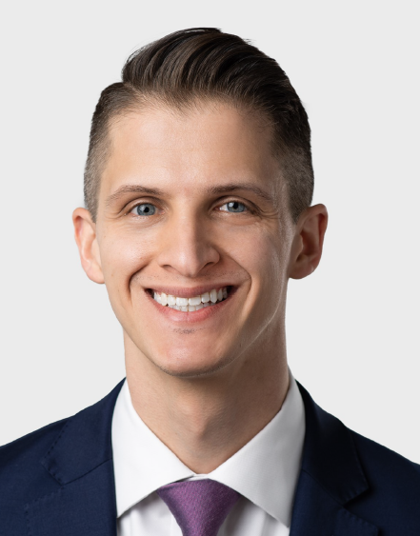  Christopher Kulik | FR-01  1 CE | Senior Practitioner Credentialing and the Concerns and Issue Related Thereto (e.g., ADEA), Etc.  Stacy Walton Long, Attorney  Christopher J. Kulik, Attorney  Topic Summary:  This presentation focuses on the issue of whether practitioner age impacts delivery of patient care and the associated regulatory and enforcement trends impacting policies designed to evaluate the cognitive and physical abilities of such practitioners. This presentation will review the evolution and impact of age and disability discrimination laws on the options available for evaluating the cognitive and physical competency of practitioners. The regulatory landscape is complex, and the Equal Employment Opportunity Commission has taken issue with these policies as demonstrated by ongoing litigation scrutinizing such practices.  Learning Objectives:  - Overview of regulatory and enforcement trends impacting late-career practitioner policies.  - Understand the intersection between employment law principles and the application of age and disability discrimination laws in the healthcare industry.  - Designing and implementing compliant late-career practitioner policies.  - Best practices and practical considerations for managing compliance risks associated with late-career practitioner policies.
10:15 am – 10:30 am |  | Morning Break
10:30 am – 10:45 am |  | Sponsor Spot - Pacific Companies - Thomas McKeever
10:45 am – 11:45 pm  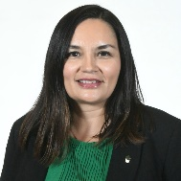  Yesenia Servin | FR-02  1 CE | CAQH: Proview, Practice Manager & Groups: Three Modules That Impact Your Enrollment Process  Yesenia Servin, CPMSM  Topic Summary:  This session is a detailed review of every section in each module; CAQH Provider Data, Practice Manager and Groups. Enrollment professionals are to comply with all the implemented CAQH updates to avoid negative revenue impacts. Create and update a solid process for maintaining your CAQH provider accounts AND understand how to partner with your practitioners to be fully compliant and structured. Review attestation requirements to speed your re-credentialing turnaround time and create an internal process to easily track CAQH attestations and maintenance.  Learning Objectives:  - Review the recent updates to each module.  - Examine best practice for implementing each module in your processes.  - Discuss the urgent sections based on each provider specialty.
11:45 am – 12:15 pm |  | Lunch
12:15 pm – 1:45 pm    Regina Plank | FR-03  1.5 CE | Advanced Practice Provider Privileging and Training: All That Is Hidden Will Be Made Clear  Regina Plank, CPMSM  Project Consultant at Parkland Health  TOPIC Summary:  Process and documents related to APP Training in Progress at Facility AND incorporating the Training in Progress into privilege criteria.  Learning Objectives:  - Warning signs to be aware of that APPs are training in your facility without oversight and a constructive, defined, approved process.  - Steps to begin the journey of developing a structured APP training process with examples.  - Tips to Incorporate the training into the APP Privilege Forms (with examples).
1:45 pm – 2:00 pm |  | Afternoon Break
2:00 pm – 3:30 pm  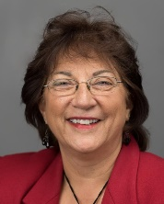  Jacquelyn Jones   Mendy Koscinski | FR-04  1.5 CE | We don’t talk about Bruno, but we do talk about Privileges  Jacquelyn M. Jones, CPMSM  Senior Consultant  HealthStream  Mendy A. Koscinski, MSHCA, RHIA, CPHQ, CPHRM  Privilege Content Consultant  HealthStream  Topic Summary:  “We Don’t Talk About Bruno” is a song from Disney’s 2021 computer-animated musical feature film “Encanto” and much like the Encanto family fears talking about Bruno, MSPs often fear talking about privileges. This session will address and alleviate a few of those fears by offering solutions to the more challenging aspects of privileging faced by MSPs today. Participants will be provided with best practice tools and strategies to help ensure their clinical privilege forms are reviewed and updated on an ongoing basis, contemporary methods, and examples of how to address the privileging of Physician Assistants and Nurse Practitioners as their practice and specialties continue to evolve and expand, and informative insights affecting the future of privileging.  Learning Objectives:  - Ongoing Maintenance of Privileges: additions, deletions, revisions  - Expansion of Nurse Practitioner Practice - Acute Care  - Physician Assistant/Associate: CAQs  - Physician Specialty Focus of Practice  - CMS Requirements for review of Surgical Specialties
3:30 pm – 3:45 pm |  | Conference Wrap Up

